Sample for PE  
SUMMER 2021  
Subject: WED201c  
Duration: 120 minutes

**Objectives:**

1. Create css files and link it to the html files.
2. Create a javascript file and link it to the html files.
3. Use html tags to create a web page.

**Background:**

In this practice exam, you are given a folder “**Resource**”. You are going to use page “index.html” to finish the exam.

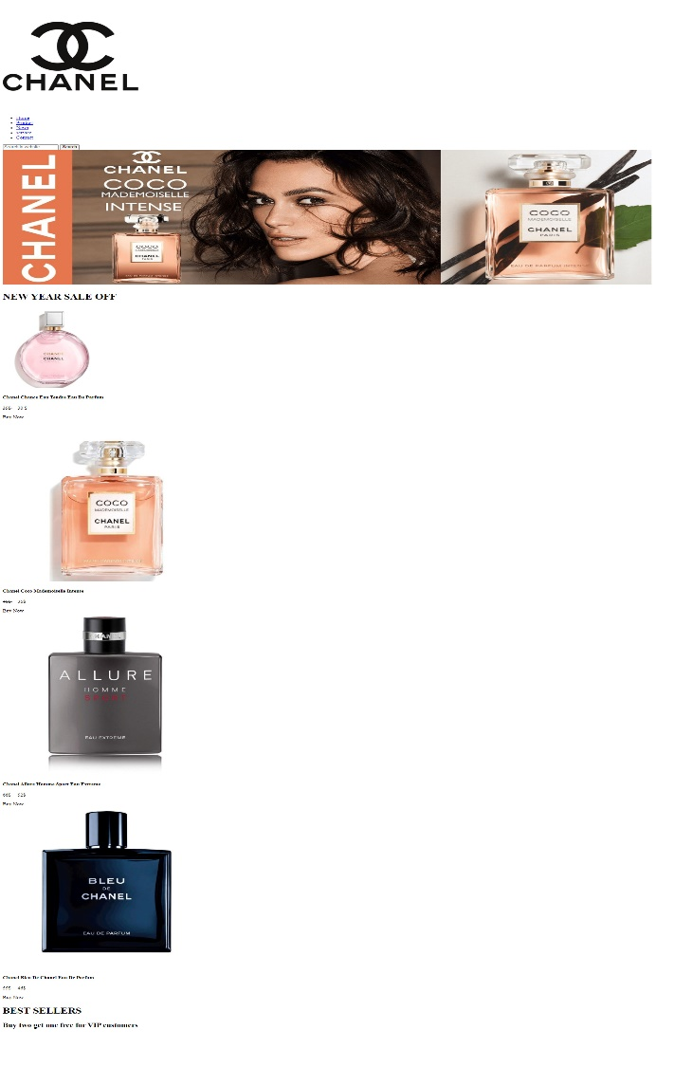**Before styling index.html page**

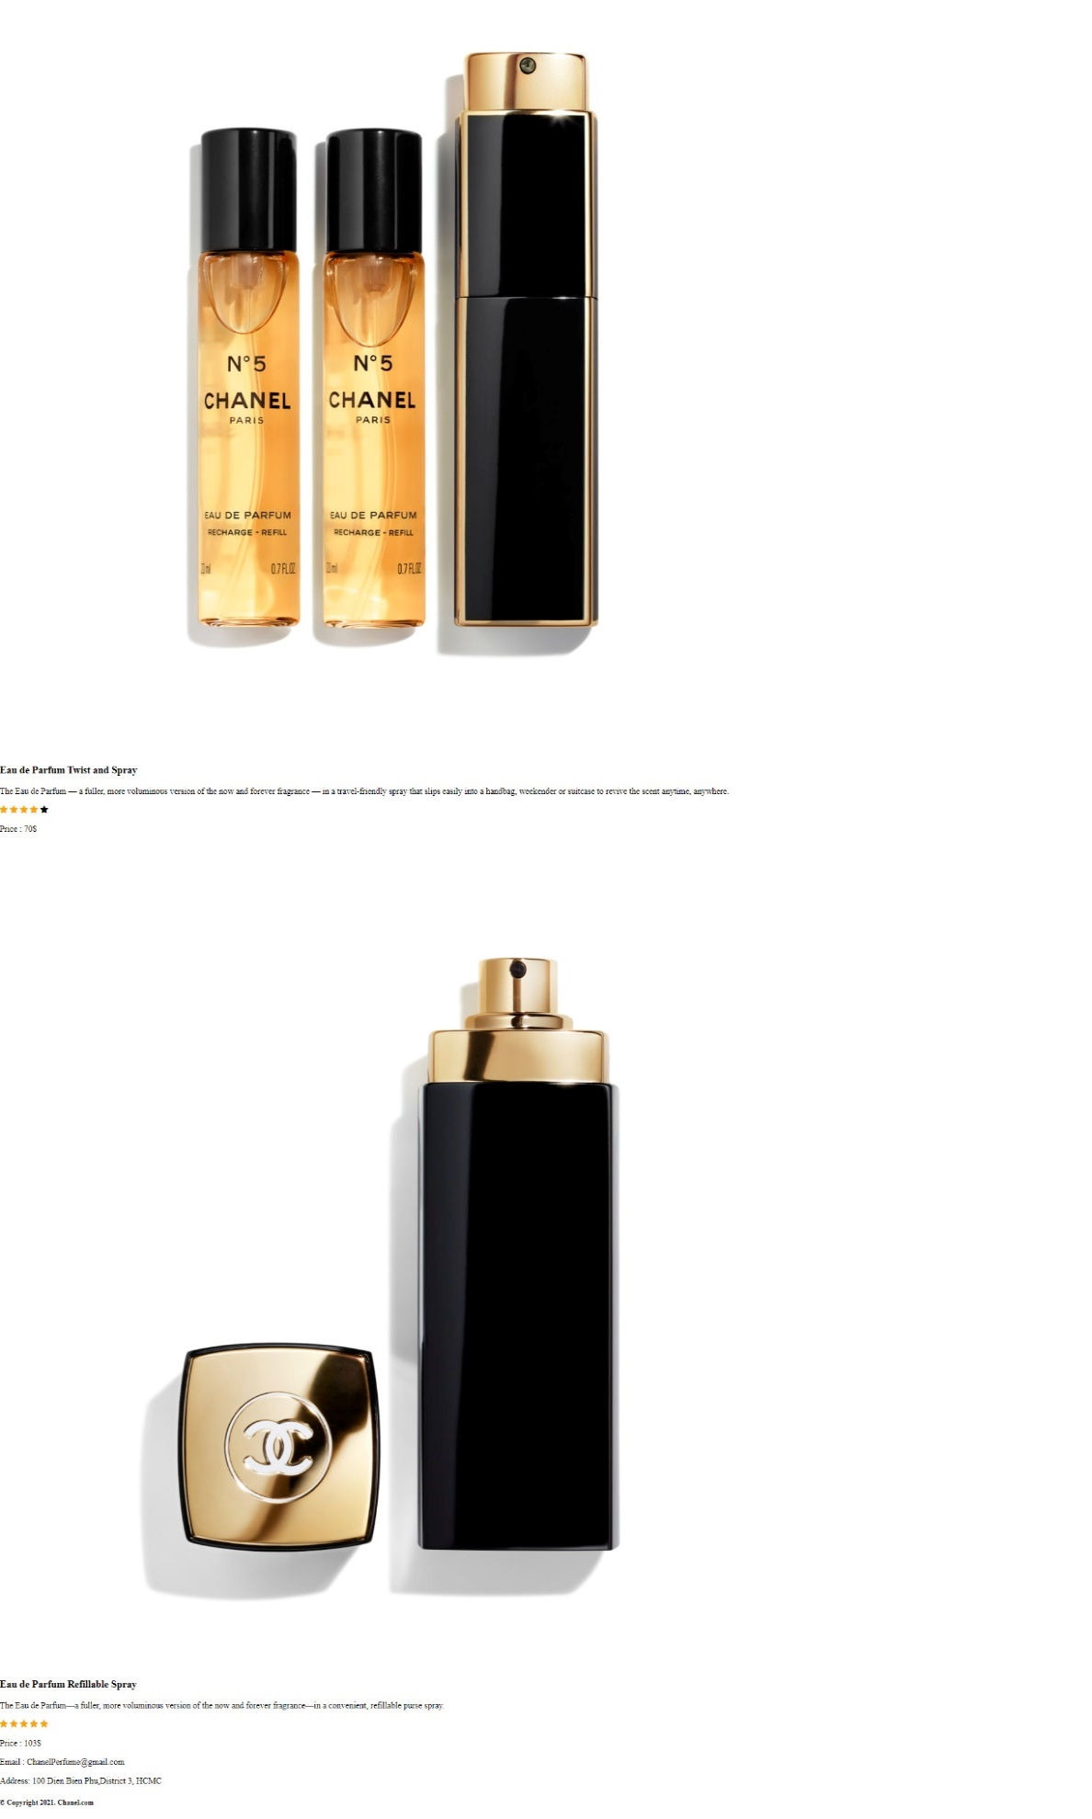

**After styling index.html page**



**Required:**

1. Create a file with the name **contact.html** and save it to **Resourse folder** as shown below:

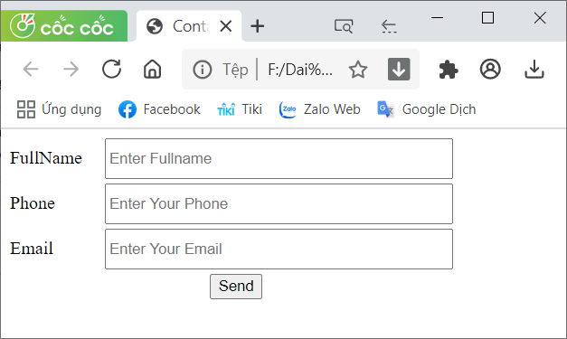

1. Create a file called **styleindex.css** to format the index.html page and save it to the **Resource folder**.
2. Create a file called **stylecontact.css** to format the contact.html page and save it to the **Resource folder**.
3. Create a file called “**mycode.js**” and save it to the **Resource folder.** You must link this file to the contact.html page.

**Evaluation**

**A. CSS [ 7 marks]**

* Use css box-shadow to cast shadows on divs [1 points].
* Use margin and padding to create the right spacing for the content [1 points].
* Use width, height to format images as shown above [1 points].
* Use color, list-style-type,background-color… to format the content [1 points].
* Use border-radius and text-align to round for the content [1 points].
* Use width, height, inline-block… to format the content of contact.html page [1 points].

1. **Javascript [3 marks]**

* Use html tags to create contact form [1.5 points].
* In file mycode.js, you must **create function** base on description:

The function Color_Background(): This function is used to set the background color when the user clicks on the corresponding control [1.5 points].

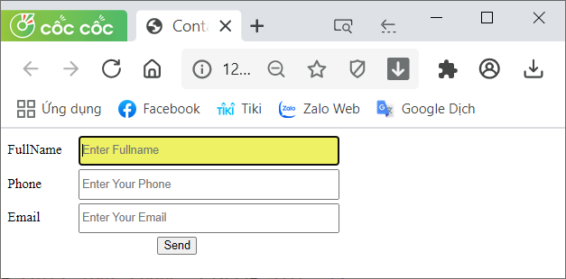

--**The end--**